Kompetenzen | Hören, an Gesprächen teilnehmen, Schreiben, kreativer Umgang mit digitalen Tools
Niveau | B1.2
Themenbereiche | Gesundheit und Ernährung
Methoden | Partnerarbeit, Gruppenarbeit, Einsatz digitaler Medien
Zeitbedarf | 1 Einheit
Eingangsvoraus-setzungen | S/S verfügen über einen ausreichend großen Wortschatz im Themengebiet Gesundheit und Ernährung und über die erforderlichen Strukturen, um die eigene Meinung und Wünsche auszudrücken
Materialien | Arbeitsblatt  1 Videofile  Beamer, Laptop (L/L)  1 Mobiles Endgerät (S/S)
Quellen | Videofile:  https://www.youtube.com/watch?v=JBCdIauR6nU
TechTools | www.mentimeter.com  www.quizlet.com

Aspiring longevity - Fight aging!
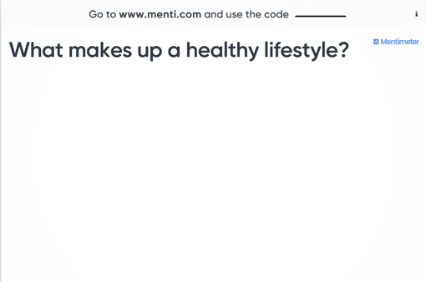
Task 1
1) What makes up a healthy lifestyle?
Your teacher will open a mentimeter for you. Go to www.menti.com and enter the code which will be given to you. Answer the question. Give more than two answers.
You may answer with short sentences.

Task 2
Discuss the following questions in groups of three to four.
- Would you like to live to be a hundred? Give reasons.
- Do you live in a healthy environment? What is a healthy environment?
- Have a look at the little map in task 3 below. These are areas where people live exceptionally long lives. Speculate about the circumstances why people live such long lives there.

Task 3
The Blue Zones Solution in 90 Seconds
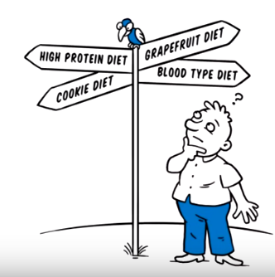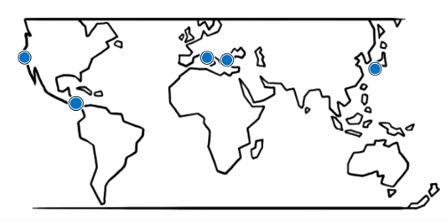
1. Have you heard of any of the
diets mentioned in the video?a) Have you heard of any of the diets mentioned in the video? Which ones?
Watch the following video: https://www.youtube.com/watch?v=JBCdIauR6nU
Work in pairs.
First, discuss what information you remember, and take notes.
Then answer the questions below.
If necessary, watch the video a second time.

- Which are the places where people live exceptionally long lives?
- People in these so-called Blue Zones suffer from fewer diseases.
Which diseases are these?
- What do the healthiest people eat according to the video?

Task 4
Work on the vocabulary. Choose ten words and phrases from the list you would like to train.
Find explanations/translations/example sentences for these expressions and check them with your teacher.
Create your own quizlet. Go to www.quizlet.com and of course share your quizlets.

If you have never worked with quizlet before, have a look at how it works first, before you create your own: https://quizlet.com/342164921/flashcards

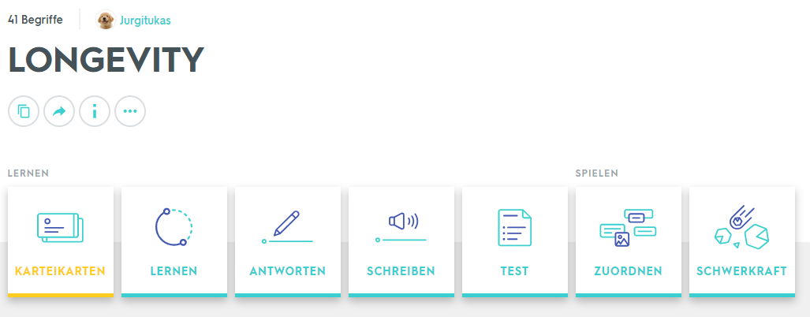

to compete for someone’s attention  hard to decide  to pick up the right diet  weight-loss program  practically useless  to deliver lasting health  to determine  lowest rates of cancer/heart diseases  global average | to distill dietary surveys  a few surprising discoveries  high carb diet  low amount of protein and fats  to snack on nuts  a handful a day  the cornerstone  to set up your surroundings

Task 5
Work in groups of three to four.
Discuss which tips for a healthy life seem most important to you and rank them.

Form new groups consisting of one member from each of the original groups.
Inform the other group members about your groups’ choice, giving reasons.

Nach dieser Lerneinheit kann ich … | ☺ | 😐 | ☹
… meine Ideen zu einem gesunden Lebensstil schriftlich und mündlich formulieren.
… einer Videoaufnahme neue Informationen zum Thema Langlebigkeit entnehmen.
… mittels quizlet neue Wörter und Strukturen lernen, um mich präziser zum Thema gesunder Lebensstil auszudrücken.

