Kompetenzen | An Gesprächen teilnehmen, Schreiben, kreativer Umgang mit digitalen Tools,
Niveau | B2
Themenbereiche | Wirtschaft und Arbeitswelt
Methoden | Einzelarbeit, Partnerarbeit, Gruppenarbeit, Einsatz digitaler Medien
Zeitbedarf | 3x50 Min.
Eingangsvoraus-setzungen | S/S verfügen über Basiswortschatz zum Themengebiet Werbung und Marketing.
Materialien | 1 Mobiles Endgerät (S/S)
Quellen | Eigene Idee, Bilderquelle: www.pixabay.com
TechTools | Moodle  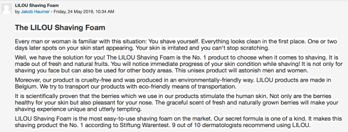  Alternative: MS Teams

You’ll be lovin’ it
Task 1
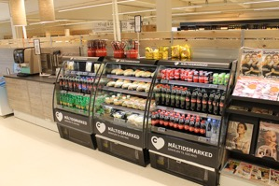
Here are different types of products:

- apparel and footwear
- baby and child products
- beauty products (e.g. skincare products, sunscreens or anti-aging lotions)
- cars
- apps
- cleaning products (e.g. toilet cleaners, air-care products or laundry detergents)
- electronics and mobile devices
- convenience foods (e.g. ready meals, frozen foods or snack foods)
- health and food supplements

- Work in pairs or small groups and choose a type of product or service you’re interested in.

- Make a 30-second-TV commercial to promote the product or service.

Write a script for the commercial and come up with a story that will communicate your message.
You should …
- describe what your product or service does
- state its benefits and how it will improve buyers’ lives
- convince them to buy
Your commercial might have different aims:
- to inform
- to persuade
- to manipulate
- to provoke
In order to fulfil your aim, use “marketing language”.
Use adjectives to make your product/service sound interesting (eg. breathtaking, mouthwatering, stylish).
Use superlatives to show that it offers something nobody/nothing else does (e.g. juiciest, latest, fastest, easiest).
Use imperatives (e.g. Just do it. Don’t wait – act now.) in order to make people buy your product/service.
Use rhetorical questions (e.g. Would you like to have skin as smooth as silk?).
Make promises (e.g. You’ll be thrilled with the results.)

- Upload your commercial to the discussion forum on Moodle by … (deadline).

Task 2
Work on your own. View the commercials that have been posted to the forum.

- Choose three that attract your attention.
- What makes these commercials interesting/attractive?
Think about the reasons and take some notes.
- Imagine you have bought and tried the products and/or services. Are you happy or dissatisfied with them?

- Leave a review for one of the products/services. Your review should:
- describe the product
- identify the problem (if there was any)
- state your opinion

If you want to find out more about how to write a good product or service review, go to https://en.oxforddictionaries.com/writing-help/writing-a-product-review

Task 3
Read the customer reviews that have been posted for your product or service.
In your pairs or groups decide who is going to post a reply.
- If it's an unhappy customer review, say what you are going to do to put things right.
- If it’s a happy customer comment, write a few words of appreciation.
Post your reply by … (deadline).

Task 4
Give each other feedback on the commercials you have produced, based on your notes from Task 2a.

Nach dieser Lerneinheit kann ich … | ☺ | 😐 | ☹
… einen kurzen Werbespot produzieren
… eine Produkt-/Servicerezension schreiben
… einen Werbespot analysieren und Gründe angeben, warum er funktioniert
… auf eine Rezension angemessen reagieren

