Kompetenzen | Hören, Schreiben, kreativer Umgang mit digitalen Tools,  An Gesprächen teilnehmen
Niveau | B2
Themenbereiche | Freizeit und Sport, Geld, Computerspiele
Methoden | Gruppenarbeit, Partnerarbeit, Einsatz digitaler Medien, Flipped Classroom
Zeitbedarf | 2 Einheiten
Eingangsvoraus-setzungen | S/S verfügen über ausreichenden Wortschatz zum Thema Sport, Gaming und Finanzen.
Materialien | Mobile Endgeräte  Kopfhörer  Laptop / Tablet je Gruppe  Papier + Stift (oder Tablet + Pen)
Quellen | Eigene Idee  Video: https://www.youtube.com/watch?v=F_GxPXXLc-w
Details zur Aufgabe | Mit dieser Aufgabe sollen auch die neuen Deskriptoren des CEF Companion Volume 2018 hervorgehoben werden.  - Task 3 fokussiert auf folgenden Deskriptor:  Relaying specific information in writing  B1+: Can relay in writing specific information points contained in texts on familiar subjects.
TechTools | 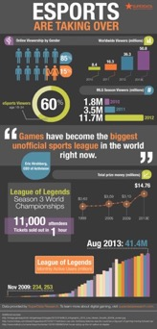  www.venngage.com  Venngage ist ein sehr attraktives Tool um Daten gut zu präsentieren. Es werden verschiedene Kategorien angeboten. Diese reichen von Infografiken über Broschüren hin zu Menükarten. Es ist also sehr vielfältig und auch sehr einfach zu bedienen. Die meisten Möglichkeiten sind gratis, sofern man sich registriert hat.  Hier (beispielhaft) eine professionell gestaltete Infografik zum Thema Esports.  (https://bc-gb.com/wp-content/uploads/2014/02/eSports-is-taking-over-INFOGRAPHIC.jpg last access: May 14,2019)

Esports
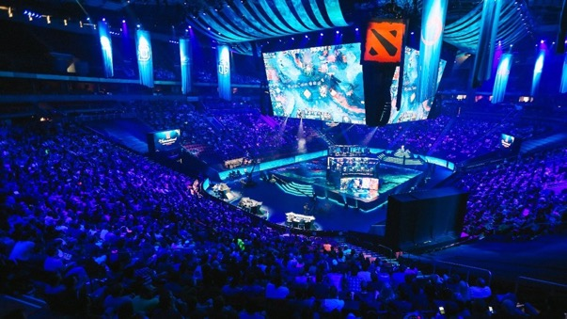
Picture taken from: https://www.thetimes.co.uk/raconteur/business/why-esports-is-attracting-global-brands-and-what-it-has-to-do-to-get-more/ (last access: May 14, 2019)
Task 1
In groups of 4-5, create a mind map collecting all the information you have on esports.
What is it, which games are played, (how) does it affect your personal life?
Include the following aspects:
- Motivation for esports
- Dangers
- Ways of playing
- Requirements
- Famous players
- Etc.
You might want to use Venngage in order to create your mind map and also to collaborate on the design with your whole team: https://venngage.com/mind-map-maker/
Just register for a free account with an email address.

Task 2
Esports – a big business
In pairs, watch the YouTube video and answer the following questions by taking notes:
- How did esports evolve?
- What is it exactly?
- In which way is it controversial?
- How has it become big business?

Task 3
Esports – an infographic
Watch the video again and in a group of 4 create an infographic about esports.
Include the information you consider essential in order to make somebody invest in esports.

Again, use Venngage to create your infographic. Keep in mind, you can collaborate online if you like.

Here are 8 tips in order to create a good infographic:
- Collect all the relevant data.
- Use a sheet of paper (or your tablet and pen) and group the information using
relevant sub-headings.
- Think about how you will structure your infographic.
- Sketch out your ideas.
- Go to Venngage.
- Choose a design or create a new one.
- Store your infographic as a .png or .jpg file.
- Share your infographic (OneDrive, Dropbox, Google Drive, etc.).

Exemplary infographic:
This is an infographic on how to customize your template. For a larger view, go to:

https://venngage.com/templates/infographics/how-to-customize-your-infographic-template-578de64d-9086-4e61-847b-df88c0e38543

Possible Follow-up Task 4
A role-play discussion

Esports have become more and more recognized as a “real” sport. Therefore, it is being discussed whether these games should become Olympic.

Flip my classroom:
Watch this TED Talk with Jonathan Pan (a professional US gamer) in order to get a general idea on this issue. Do that before the role-play lesson.

https://www.youtube.com/watch?v=xPxZTqRkvCc

Work in groups of 4 (A, B, C and D).
Discuss the following question:

“Should esports be part of the Olympic Games in L.A. in 2028?”

(picture taken from: Wikipedia.com)

Here are the four roles.
A: a professional gamer who wants esports to be part of the Olympics 2028
B: a very skeptical sportsperson whose sport is already Olympic.
C: a member of the Olympic committee (rather skeptical about the proposal)
D: a member of the Olympic committee (neutral position)

Step 1: Choose a role.
Step 2: Prepare for the discussion. The video you have watched (TED Talk) will help you.
You can prepare your arguments individually or in pairs (A+B, C+D).
Step 3: Discuss the idea.
Step 4: Come to a conclusion.
Step 5: Prepare a short written statement which summarizes the decision taken, giving
reasons.

Nach dieser Lerneinheit kann ich … | ☺ | 😐 | ☹
…, mit Hilfe eines digitalen Tools, Mindmaps gestalten.
... ein Video zum Thema Esports verstehen und die wichtigsten Informationen in einer Infografik darstellen.
… die wirtschaftliche Bedeutung von Esports hervorheben.
(... eine Diskussion zum Thema Esports führen.)

