Gegenstand: Didaktik (und Praxis)
Topic: Total Physical Response / language acquisition
Farbcode:
Blau hinterlegt. = Bloom’sche Taxonomie angewandt.
Grün hinterlegt = Scaffolding angewandt
Activity Type/Method  and  Classroom Format (group work, pair work, …) | - Brainstorming  - Working with new words – word cloud  - Watching a video, note-taking (= understanding)  - Comparing notes with partners (= remembering)  - Discussion of pros and cons (= analysing)  - Create/plan a short TPR session (= creating)  - Present your lesson plan to classmates and give feedback  - (Possible follow-up:) Try out the TPR session in practice nursery school or with classmates (= applying)  - Debriefing session, matching exercise
Time | 2x 50 min.
Resources (handout, book, …) | Video (06:57 min.): Total Physical Response  https://www.youtube.com/watch?v=1Mk6RRf4kKs (17.01.2020)  Student’s worksheet
Content-Related  Learning Outcome | - Students know the principle of the TPR-method  - Students can apply the knowledge to create/plan a short TPR session  - (Students can apply the knowledge and carry out the TPR method in the practice nursery)
Language-Related Learning Outcome | - Students know basic words and expressions for talking about the TPR method of language acquisition  - Students know different phrases for discussion and use them in the discussions
Additonal materials | Aus: Isolde Plangg-Tauschitz/Sabine Zangerl. Careers in Childcare NEU – Fachsprache Englisch für Elementarpädagogik und Kinderbetreuung, Veritas Verlag, 2017. (Schulbuchnummer: 185.116)  Unit 1: Activities for children (p 8-20)  Unit 8: Supporting language development (p 120-125)
Solutions Task 5 | Solution: 1g, 2c, 3a, 4h, 5b, 6i, 7e, 8f, 9d

Bezug zum BAfEP-Lehrplan (BGBl. II - Ausgegeben am 27. Juli 2016 - Nr. 204):
III. Jahrgang:
5. Semester (Kompetenzmodul 5):
Bildungs- und Lehraufgabe:
Die Schülerinnen und Schüler können
im Bereich „Lernen“
- Mehrsprachigkeit unter besonderer Berücksichtigung des Zweitspracherwerbs argumentieren.
Lehrstoff:
Bereich „Lernen“:
Ausdrucksformen des Kindes in den Bereichen Bewegung, Musik, Grafik, Kommunikation, Erst- und Zweitspracherwerb, Mehrsprachigkeit

IV. Jahrgang:
8. Semester (Kompetenzmodul 8):
Bildungs- und Lehraufgabe:
Die Schülerinnen und Schüler können
im Bereich „Lernen“
- die Entwicklung lernmethodischer Kompetenzen erklären,
- Instrumente zur Einschätzung der Sprachentwicklung vergleichen,
- Maßnahmen zur Sprachförderung auf Grundlage systematischer Einschätzung entwickeln.
Lehrstoff:
Lernmethodischer Ansatz, Einschätzung und Förderung der Sprachentwicklung unter besonderer Berücksichtigung des Zweitspracherwerbs, Bildungsorte außerhalb elementarer Bildungseinrichtungen

Praxis (S80):
6. Semester (Kompetenzmodul 6):
Bildungs- und Lehraufgabe:
Die Schülerinnen und Schüler können
im Bereich „Kommunikation und Sprache“
- Sprachkompetenz des 0 bis 6 -jährigen Kindes fördern.
Lehrstoff:
Bereich „Kommunikation und Sprache“:

Total Physical Response

Task 1:
Work on your own.
What do you associate with the terms “Total Physical Response” and “Action Story”?
Take notes and share your ideas with a partner for 1-2 minutes.

Task 2:
Work on your own.
Look at the word cloud and together with a partner try to find out what the words mean. You can also look up unknown words.
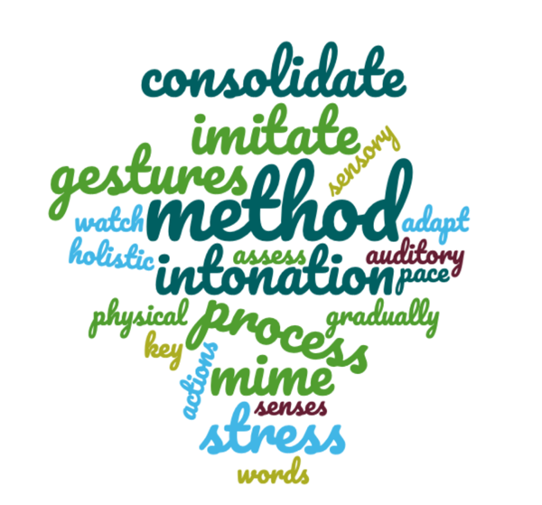
Task 3:
Work on your own.
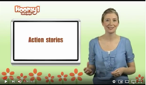
Watch the video and fill in the table.
https://www.youtube.com/watch?v=1Mk6RRf4kKs
Compare your notes in pairs of three.

Action stories
Phase 1
Phase 2
Phase 3
Phase 4
Phase 5

Task 4:
Get together in pairs.
Discuss why TPR is a holistic method.
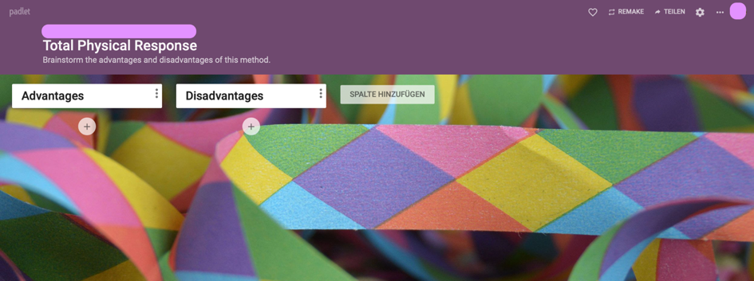
Collect advantages and disadvantages of this method via Padlet.

Task 4:
Work in groups of four.
Search for a song, story or a nursery rhyme and create a lesson plan for a short TPR session.
Make a list of materials you need.
Present your lesson plan to your classmates and give each other feedback.

Task 5:
Match the sentence halves to summarise the information about TPR. There are two sentence endings that you do not need to use:

- TPR was created by | - their parents/carers demonstrate and instruct
- TPR is based on the experience | - rather than learn it as we do additional languages.
- When children learn their mother tongue | - because language learning happens naturally.
- No one requires very small children to speak, | - of how humans learn their first language.
- The result is that we acquire our mother tongue, | - because with the physical action all students are able to understand and use the target language.
- TPR has a lot of benefits | - supports effective learning.
- The combination of movement with language | - physical activity will respond well to TPR.
- Kinaesthetic learners who respond well to | - American psychologist Dr. James Asher.
- It works well with mixed-ability classes | - when they do not want to.
 | - only to listen and understand.
 | - especially for beginners and young learners

Possible follow-up activities:
1. Prepare the materials (flashcards…) for the TPR session and try out the activity in your practice nursery school or with your classmates. Give each other feedback.

Pictures taken from: https://thenounproject.com und Pixabay

