Task 1)
Work on your own.
IMPROVE YOUR WORD POWER
Every new situation brings along new word formations and the new disease is no exception.

- Write out the words
- Try to explain their meaning and
- Form a sentence

Teacher’s notes:

Link to FRAMAPAD, ETHERPAD or ZUMPAD etc. (hier Link einfügen – SuS können gleichzeitig an einem Dokument arbeiten)

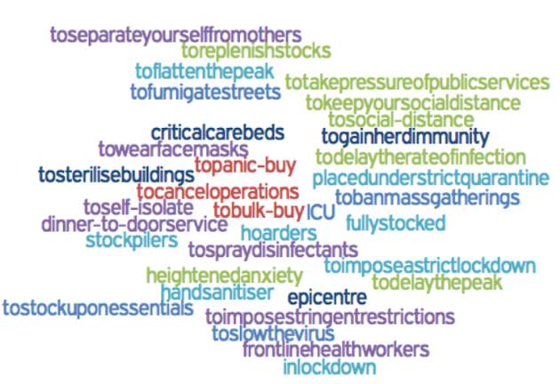

Sie können Ihr geteiltes Dokument wie folgend beginnen und mit Ihren Schülerinnen und Schülern gemeinsam weiter arbeiten.

IMPROVE YOUR WORD POWER! CORONA LANGUAGE

to separate yourself from others - to stay away from each other sich von anderen abgrenzen
example: The corona virus is very contagious; therefore, it is necessary to separate yourself from others.

to impose stringent restrictions

Task 2)
Work on your own.

Reading a)
Search the net for a critical article on the current situation. Find out whether the source is reliable or not. Here are some tips how to distinguish between real or fake news:
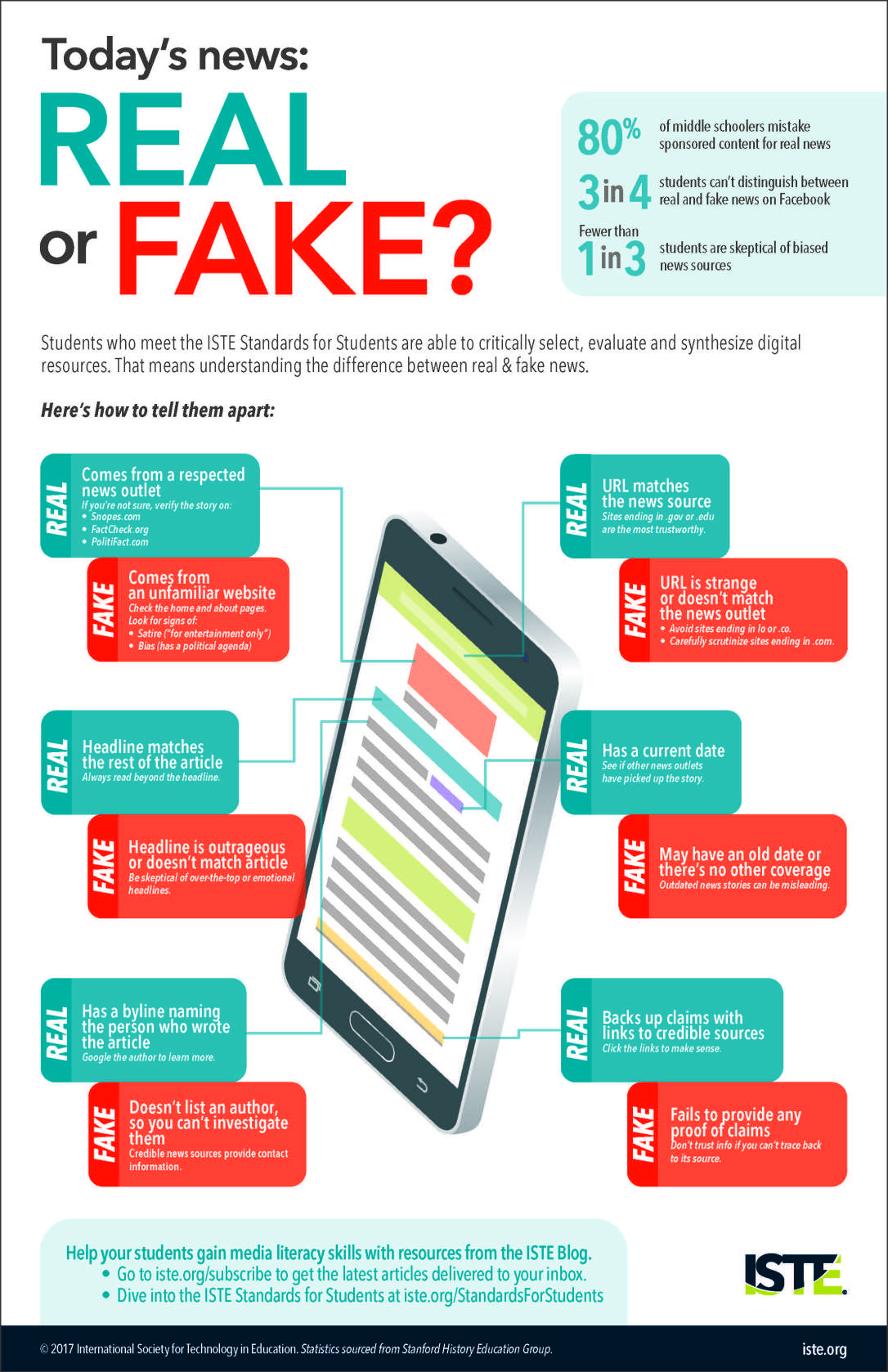

https://www.dailyinfographic.com/avoid-fake-news

Reading b)
Take notes of any new/interesting/surprising facts/ideas/information you’ve come across.

CC BY BECRIS

c) Please insert the links of the read articles here:

…

ENGLISH TEACHER:
https://www.nytimes.com/2020/03/20/opinion/coronavirus-california.html
https://www.allsides.com/topics/coronavirus?search=coronavirus

Task 3)
Speaking

a) Reflect critically on what you’ve read and record an audio (2-3 minutes)

- Describe the current situation (state of being/government measures/people’s
reactions etc.)
- Give some facts/ideas you have read about (don’t forget to cite the source)
- Talk about the impact of the corona virus on your life
- Give a positive outlook for the future

b) Please send the audio via TEAMS / SIGNAL to your teacher. You will get an oral feedback.

