Task 1)
Work on your own.

Take 5 minutes.
Browse through all your memes (funny images and videos you’ve recently received from other people). Most of them were produced in relation to the current situation we all live in.

Find the one you like best.

Task 2)
Describe the video / the picture orally and record your voice. Send this voicemail to your group via your Teams Chat.

Task 3)
- Listen to all the voicemails you’ve received and try to find out whether you have received the same video / image.
- If you feel you know the video / image, send it to the group by adding the person’s name using an @.
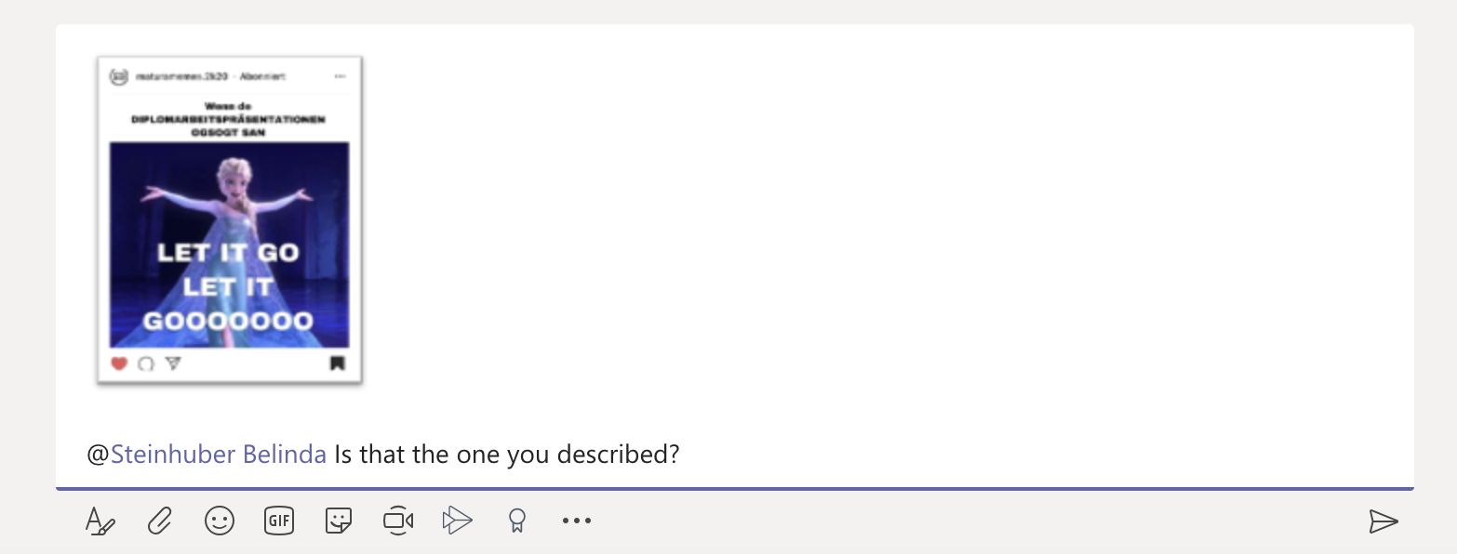

In the end you all should have listened to all voicemails and at the end of the lesson all the memes must be found in your chat.

