My kind of company?

Task 1
Work in pairs during the whole time. Either phone one another or chat via a medium of your choice.

Please speak English with one another (!). It is valuable practice time + your classmate is an excellent listener and will not correct you but rather help you :-D.

Decide on a company you both could imagine working for. (Could be anywhere. Could be any job).

Task 2
Find out about that particular company. These aspects should be included (if possible).
- History
- Products / Services
- People
- Figures (e.g. revenue, stock market value, etc.)

Task 3
Create an infographic about your company. You can use www.canva.com or www.venngage.com or any other app you like.

Don’t copy any existing infographic.
Try to make it informative as well as attractive and easy to understand.

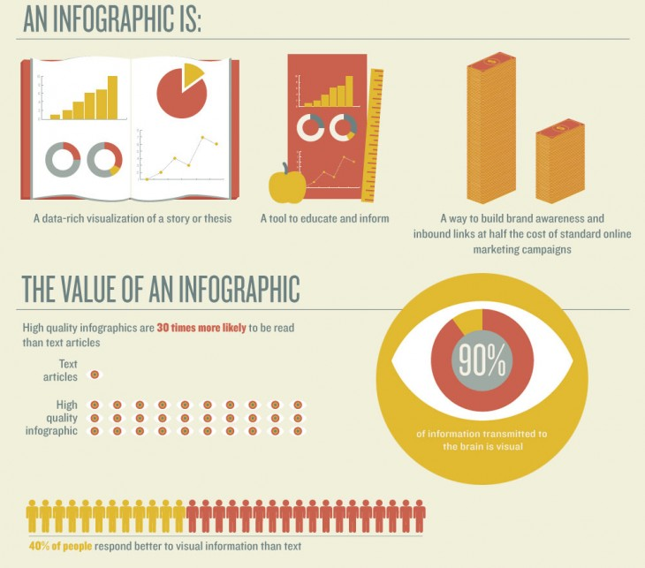
Taken from: https://cdn0.tnwcdn.com/wp-content/blogs.dir/1/files/2013/10/what-is-an-infographic-excerpt1-730x643.jpg (last access: March 20, 2020)

Task 4
Send the infographic to your teacher (or share it) via MS Teams.

