Topic: Human Rights / Fight for Equality / Racism / Violence

ab Niveau B1+

Voraussetzungen:
Der/Die Lehrer/in erstellt ein Padlet (https://de.padlet.com/), ein Wiki in MS Teams oder einen Blog auf Blogger (https://www.blogger.com/) für die Blog Posts.
Die über Blogger erstellten Blogs sind grundsätzlich öffentlich. Bei der schulischen Nutzung empfiehlt es sich, die Leserschaft zu begrenzen, z.B. auf die Schüler/innen der Klasse/Gruppe. Dies ist möglich indem man die Einstellungen entsprechend abändert.

TASK 1: WATCHING & READING
Lead-in
Do the vocabulary tasks on the handout “Recent Protest across the US – Vocab Exercises”.

Step 1
Watch the video “Scenes from riots and protests across the US”.
https://www.youtube.com/watch?v=-J20j8BAfy0
You may of course watch it more than once if necessary.

Step 2
Watch the video “Große Reden: Martin Luther King – I have a dream”.
https://www.arte.tv/de/videos/074567-005-A/grosse-reden-martin-luther-king/
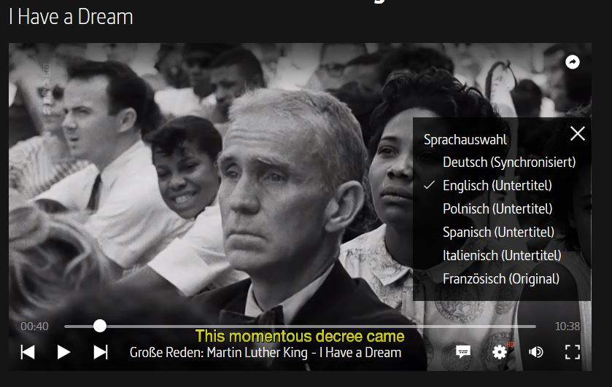
You can choose to watch the video in German or in English with subtitles. In the English version, the comment is in French (as it is an ARTE production), which is great if you are learning French as a second language. If it disturbs or distracts you, watch the German version.

The arrow shows where you can find the button “Sprachauswahl”.

Voluntary activity: If you want more information on the March on Washington, you can also watch the video “The March On Washington: The Spirit Of The Day”.
https://www.youtube.com/watch?v=5Q_I_2m5TbA

Step 3
Read the text “George Floyd death: Violence erupts on sixth day of protests” and answer the questions (handouts Fight for Equality pages 4-6).
Write your answers into a word document and upload it to … (e.g. Teams) by ….

Step 4
Read the text about Darnella Frazier, entitled “Die Zeugin der Polizeigewalt” (handout Fight for Equality page 6).
TASK 2: SPEAKING
Find a partner in the group that you don’t meet at school at the moment.
Get in touch with your partner, for example through MS Teams.
Exchange your thoughts on the following questions:
- Which of the 4 documents (step 1-4) did you find most interesting? Why?
- What is the connection between the March on Washington in 1963 and the situation today?

TASK 3: WRITING
Part 1
Write a short summary of the discussion you had with your partner.
Send the summary to … by …

Part 2
After having informed yourself about the riots in the US and their origin, you decide to react.

Write a post for the blog “Fight for Equality” in which you
- state whether you think it was a good idea of Darnella to make and publish the video
- explain how you feel about the protests

Post your text on the padlet/the blog by …
Here’s the link: …

Recent Protest across the US – Vocab Exercises
1. Match the expressions with their explanations.
- a curfew  - a riot  - a rally  - a vigil  - (police) custody  - backlash  - riot officer  - domestic emergency  - excessive force  - casualty | _____  _____  _____  _____  _____  _____  _____  _____  _____  _____ | - much more violence than is reasonable or necessary  - a strong, negative, and often angry reaction to something that has happened, especially a political or social change  - someone who is injured or killed in an accident or military action  - the period of time during which people must not go outside  - something dangerous or serious that happens in people’s home country suddenly or unexpectedly and needs fast action in order to avoid harmful results  - a quiet political protest held at night  - a situation in which someone is kept in prison or held by the police until they go to court for trial  - a violent protest by a crowd of people  - a public meeting that a lot of people go to in order to support someone or something or to protest against someone or something  - a special policeman trained to deal with noisy, violent groups

2. Match the verbs and nouns (sometimes there is more than one possibility).
Then use the expressions that you have found to translate the German phrases.
- to impose  - to disperse  - to loot  - to reignite  - to deploy  - to set alight  - to use  - to charge  - to condemn | _____  _____  _____  _____  _____  _____  _____  _____  _____ | - excessive force  - troops  - violent protests  - a curfew  - crowds  - police vehicles  - shops  - anger  - at someone

eine Ausgangssperre verhängen  die Menschenmengen zerstreuen/auflösen  Geschäfte plündern  den Ärger neu entfachen  Truppen entsenden  Polizeifahrzeuge anzünden  exzessive/übertriebene Gewalt anwenden  auf jemanden losgehen/jemanden angreifen  gewalttätige Proteste verurteilen | ______________________________________________  ______________________________________________  ______________________________________________  _____________________________________________  ______________________________________________  ______________________________________________  ______________________________________________  ______________________________________________  ______________________________________________

George Floyd death: Violence erupts on sixth day of protests

1 June 2020 Source: https://www.bbc.com/news/world-us-canada-52872401
Violence has erupted in cities across the US on the sixth night of protests sparked by the death in police custody¹ of African-American George Floyd.
Dozens of cities imposed curfews, but many people ignored them, leading to stand-offs and clashes.
Riot police faced off with protesters in New York, Chicago, Philadelphia and LA, firing tear gas and pepper bullets to try to disperse crowds.
Police vehicles were set on fire and shops were looted in several cities.
The country is experiencing the most widespread racial turbulence and civil unrest since the backlash to the assassination² of Martin Luther King in 1968.
The outpouring of anger began last Tuesday, after a video showed Mr Floyd being arrested in Minneapolis and a white police officer continuing to kneel on his neck even after he pleaded he could not breathe and fell unconscious.
More than 75 cities have seen protests, with streets only days ago deserted because of coronavirus full of demonstrators marching shoulder to shoulder. Some US officials have warned of protest-connected virus outbreaks.
The Floyd case has reignited deep-seated anger over police killings of black Americans and racism. It follows the high-profile cases of Michael Brown in Ferguson, Eric Garner in New York and others that have driven the Black Lives Matter movement.
For many, the outrage also reflects years of frustration over socio-economic inequality and discrimination, not least in Minneapolis itself, where George Floyd died.

What happened in the latest protests?
About 16,000 troops from the National Guard - the US reserve military force for domestic emergencies - have been deployed to deal with the unrest across 24 states and Washington, DC, where crowds once again gathered near the White House on Sunday night.
Demonstrators lit fire to buildings there, including a historic church known as the church of the presidents, and threw stones at riot officers. Police used tear gas in response.
In Louisville, Kentucky, a man was shot dead in a confrontation between protesters, police and the National Guard after midnight. Shots were fired at police officers and guard troops as they moved to disperse a crowd in a car park and they "returned fire", leaving one man dead, Louisville Metro Police said.
As on Friday and Saturday, demonstrations that had been peaceful during the day again descended into violence as night fell.
Police vehicles were vandalised and set alight in several cities, while riot officers continued to respond with tear gas and flash grenades³.
At least 4,400 people have been arrested in several days of protests, according to the Associated Press news agency, for offences including blocking motorways, looting and breaking curfew.
On Monday, President Trump told state governors in a videoconference that they looked "weak", according to leaked audio obtained by CBS. "You have to dominate, if you don't dominate you're wasting your time," the president reportedly said.
________________________________________________________________
Some helpful words:
1 police custody – Polizeigewahrsam 2 assassination – Ermordung 3 flash grenades – Blendgranaten
A 19:00 curfew has now been imposed in Washington DC for Monday and Tuesday nights.
In Minneapolis, a lorry driver was arrested after reportedly breaching a road barrier before speeding towards a crowd of protesters marching along a major motorway. The driver was taken to hospital with minor injuries and later to the county jail.
There were no immediate reports of other casualties.
Minnesota's Governor Tim Walz said the motive of the driver was unclear, adding: "To not have tragedy and many deaths is simply an amazing thing."
Many videos shared on social media appeared to show riot police responding disproportionately to demonstrators. In Atlanta, Georgia, two officers were sacked on Sunday for using excessive force - including using a taser on two young college students.
Dozens of journalists have also spoken out about being targeted by police despite making clear they are with the media. A BBC cameraman was charged at by a shield-carrying officer near the White House.
There have also been protests in European cities, including London, Dublin, Berlin, Zurich and Brussels.
Terrence Floyd, George's younger brother, told ABC News he condemned the violent protests, saying his brother stood for peace.
"I'm outraged too," he said. "Sometimes I get angry... I want to go crazy. My brother wasn't about that. My brother was about peace. You'll hear a lot of people saying: 'He was a gentle giant.'
"I just had to come down here to speak to people, and let people know, just channel your anger elsewhere. Don't tear up your town."

What happened to George Floyd?
On the evening of 25 May, police were called to a grocery store where George Floyd had allegedly paid for cigarettes with a counterfeit⁴ $20 note. They found him in his car outside and tried to put him in a police vehicle, but Mr Floyd dropped to the ground, telling officers he was claustrophobic.
According to police, he physically resisted and was handcuffed. Video of the incident does not clearly show what happened at that point.
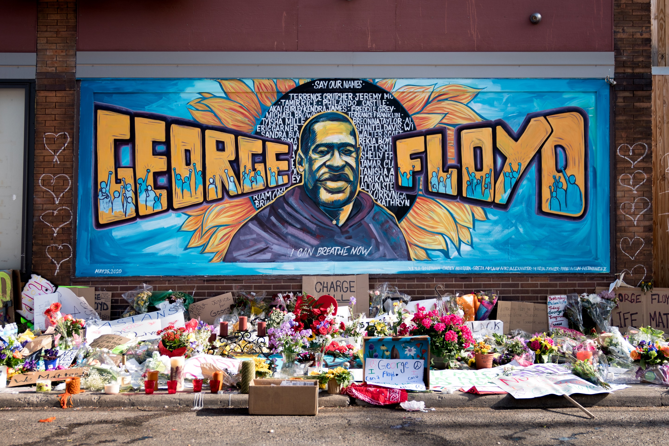A memorial to George Floyd near the spot where he died while in police custody in Minneapolis

Picture: Lori Shaull https://www.flickr.com/photos/number7cloud/49959004213/
Downloaded from Wikimedia Commons

Bystander footage shows three police officers kneeling on the unarmed Mr Floyd, with officer Derek Chauvin's knee on his neck. Mr Floyd can be heard saying "please, I can't breathe" several times and "don't kill me" but Mr Chauvin does not remove his knee despite pleas from bystanders.
According to a preliminary autopsy, the police officer had his knee on Mr Floyd's neck for eight minutes and 46 seconds - almost three minutes of which was after Mr Floyd became non-responsive⁵.
Nearly two minutes before Mr Chauvin removed his knee the other officers checked Mr Floyd's right wrist for a pulse and were unable to find one. He was taken to hospital and pronounced dead around an hour later.
Mr Chauvin, 44, has been charged with murder.
______________________________
Some helpful words: 4 counterfeit – gefälscht 5 to become non-responsive – keine Reaktion mehr zeigen

Questions text 1 „George Floyd death“:
- How did the riot police react to the protests?
- What are the reasons for the current protests, apart from the death of George Floyd?
- What was the reason for the protests in 1963?
- Why was a lorry driver arrested in Minneapolis?
- What examples are given to show that the police used excessive force?

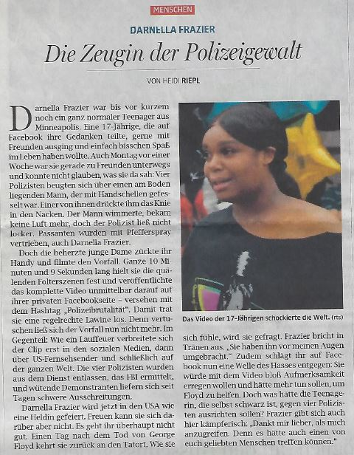
Text 2:
OÖ Nachrichten, 3. Juni 2020

Solutions Vocab Tasks
1. Match the expressions with their explanations.
- a curfew  - a riot  - a rally  - a vigil  - (police) custody  - backlash  - riot officer  - domestic emergency  - excessive force  - casualty | __ d __  __ h __  __ i __  __ f __  __ g __  __ b __  __ j __  __ e __  __ a __  __ c __ | - much more violence than is reasonable or necessary  - a strong, negative, and often angry reaction to something that has happened, especially a political or social change  - someone who is injured or killed in an accident or military action  - the period of time during which people must not go outside  - something dangerous or serious that happens in people’s home country suddenly or unexpectedly and needs fast action in order to avoid harmful results  - a quiet political protest held at night  - a situation in which someone is kept in prison or held by the police until they go to court for trial  - a violent protest by a crowd of people  - a public meeting that a lot of people go to in order to support someone or something or to protest against someone or something  - a special policeman trained to deal with noisy, violent groups

2. Match the verbs and nouns (sometimes there is more than one possibility).
Then use the expressions that you have found to translate the German phrases.
- to impose  - to disperse  - to loot  - to reignite  - to deploy  - to set alight  - to use  - to charge  - to condemn | __ d __  __ e __  __ g __  __ h __  __ b __  __ f __  __ a __  __ i __  __ c __ | - excessive force  - troops  - violent protests  - a curfew  - crowds  - police vehicles  - shops  - anger  - at someone

eine Ausgangssperre verhängen  die Menschenmengen zerstreuen/auflösen  Geschäfte plündern  den Ärger neu entfachen  Truppen entsenden  Polizeifahrzeuge anzünden  exzessive/übertriebene Gewalt anwenden  auf jemanden losgehen/jemanden angreifen  gewalttätige Proteste verurteilen | to impose a curfew  to disperse crowds  to loot shops  to reignite the anger  to deploy troops  to set alight police vehicles  to use excessive force  to charge at someone  to condemn violent protests

