WRITING: Describing and comparing
The Vegetarian Food Pyramid | The Healthy Eating Pyramid
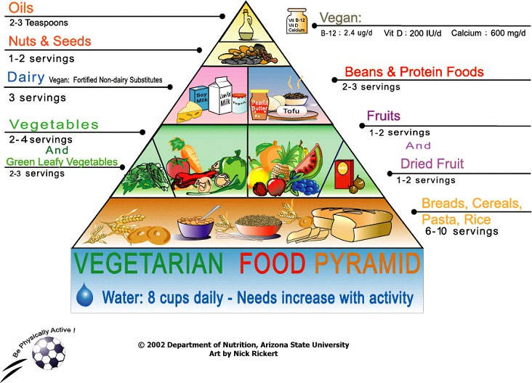 | 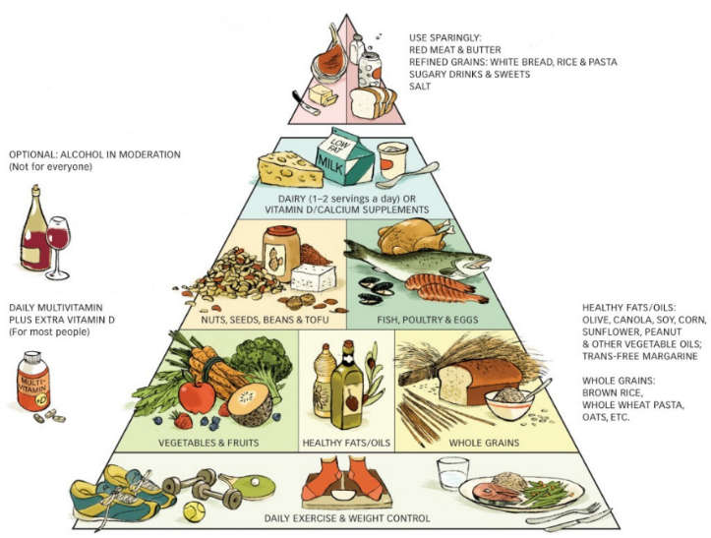
Sources: Arizona State University, Harvard School of Public Health

Look at the different food pyramids. Compare them and tell your partner any similarities and differences you have noticed. Write at least five of them down. (full sentences!)

Language for describing and comparing:

Describing | Comparing
The …. pyramid consists of …. steps/layers.  Step/layer 1 is composed of/made up of/comprises…  Above/below this step you find….  The smallest/biggest amount of… can be found at the top/at the bottom/in the middle of the pyramid.  … should be preferred./… should be eaten moderately./… should be avoided. | The ... pyramid has more/less/fewer/no …. (than)…  One similarity/difference is…  The most obvious difference is…  It is easy to see that…  While the …. pyramid includes…., the … pyramid…  On the contrary/conversely/instead/…  Similarly/likewise/equally/…

Similarities and differences between pyramids:

- …..
- …..
- …..
- …..
- …..

