Olive Oil Production Process

- FILM: Put the stages of olive oil production in the correct order:

The highest quality olive oil is produced by „cold pressed“(below 27°C).
The finished olive oil is stored in steel tanks.
Then the fruit is sent directly from the harvester to the grinders.
A hydraulic press squeezes the oil from the pulp.
Olive oil is filled in green glass bottles, to filter out harmful UV light.
In the production plant, the fruit is washed.
In a second step, the fruit is ground more gently.
First the olives are harvested.
The remaining pulp is collected and used as fertilizer or animal feed.
The olive pulp is pressed between mats.

- FOCUS on LANGUAGE:

Highlight all the verbs in the sentences of exercise a). Which verb form is usually used? The _ _ _ _ _ _ _! Why is this verb form used?

Change the following sentences so that the verb form is used:

Workers wash the fruit.
The filling machine fills olive oil in green glass bottles.
Modern grinders grind the fruit more gently.

Underline the phrases which signal the sequence of events in exercise a). (e.g. First, then, finally,…)

- INFOGRAPHIC:

Pair work: Match the production stages with the infographic.

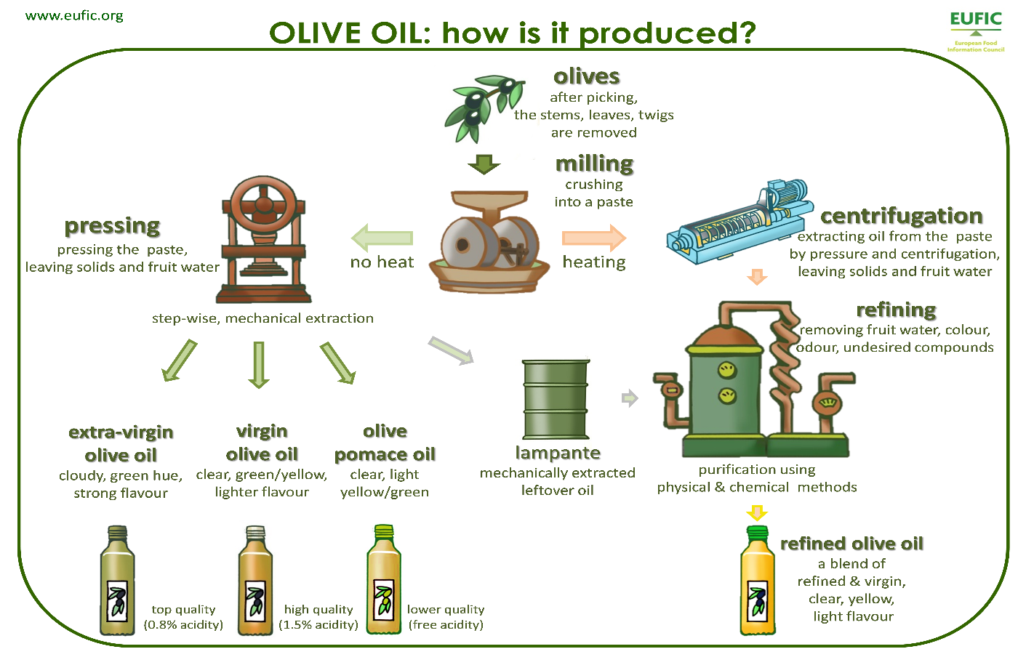
Use the language support box to describe the infographic to your partner:
Language support:
First  Secondly  After milling  Then  Finally | the olives  the paste  the warm oil  Olive oil | are separated  is either heated or not heated.  is extracted  can be divided | from  by  into | stems, leaves and twigs.  centrifugation.  three categories.

Vocabulary:
to store = lagern
steel tanks = Stahltanks
harvester = Erntemaschine
grinder = Mühle
to grind – ground – ground = mahlen
hydraulic press = hydraulische Presse
to squeeze = drücken, (aus-)quetschen
pulp = Fruchtfleisch
production plant = Fabrik
to harvest – harvested – harvested = ernten
fertilizer = Dünger
animal feed = Tierfutter

Sources:
Film: https://www.youtube.com/watch?v=aieNV3V4b_s
Infographic: http://www.eufic.org/en/whats-in-food/article/olive-oil-infographic

Solutions:
Olive Oil Production

- FILM: Put the stages of olive oil production in the correct order:

5 | The highest quality olive oil is produced by „cold pressed“ (below 27°C).
9 | The finished olive oil is stored in steel tanks.
3 | Then the fruit is sent directly from the harvester to the grinders.
7 | A hydraulic press squeezes the oil from the pulp.
10 | Olive oil is filled in green glass bottles, to filter out harmful UV light.
2 | In the production plant, the fruit is washed.
4 | In a second step, the fruit is ground more gently.
1 | First the olives are harvested.
8 | The remaining pulp is collected and used as fertilizer or animal feed.
6 | The olive pulp is pressed between mats.

- FOCUS on LANGUAGE:

Highlight all the verbs in the sentences of exercise a). Which verb form is usually used? The P A S S I V E! Why is this verb form used? To emphasize the action, not the subject. (in production processes it is often more important to know what is done than who does it – see sentences below)

Change the following sentences so that the verb form is used:

Workers wash the fruit. | - The fruit is washed (by workers).
The filling machine fills olive oil in green glass bottles. | - Olive oil is filled in green glass bottles (by the filling machine).
Modern grinders grind the fruit more gently. | - The fruit is ground more gently (by modern grinders).

