1) VIDEO TASK
https://www.youtube.com/watch?v=9-xdy1Jr2eg&t=2s

What are the SDGs? When were they established?
Agreed on by ______ countries in __________ the SGDs are the world’s new action plan for the next _____ years to
- ___________extreme poverty and hunger Beseitigung von Armut und Hunger
- fighting ________________ Kampf um Gleichberechtigung
- _______________ climate change Bekämpfung des Klimawandels
- achieve s______________ development for all nachhaltige Entwicklung für alle erreichen

The SDGs followed the Millennium Development Goals to tackle _____________________________. = Entwicklungsfragen anzugehen
- positive consequences so far
- number of people living in extreme poverty _____________by more than half verringert
- more boys and girls _______________ primary schools besuchen
- _______________ to water and essential medicine Zugang

Today over 800 million people still live in extreme poverty. They are also ______________ (am anfälligsten) to the increasing ______________ (Auswirkungen) from climate change and environmental _______________ (Zerstörung). Years of ___________ (hart erkämpfter) progress fighting poverty could easily be wiped out by even small conflicts, economic crises or natural disasters.

Which regions achieve less progress?
Give examples for marginalized groups:
Human ___________________ (Wohlstand) must go hand in hand with protecting the planet.

Name some of the 17 sustainable development goals

The SDGs tell us we should _______________________________.
Together with the __________________________ and the Pope’s encyclical laudato si the SDGs provide a new framework for approaching sustainable development.

2) PRESENTATIONS (nach Gruppenpuzzletechnik)

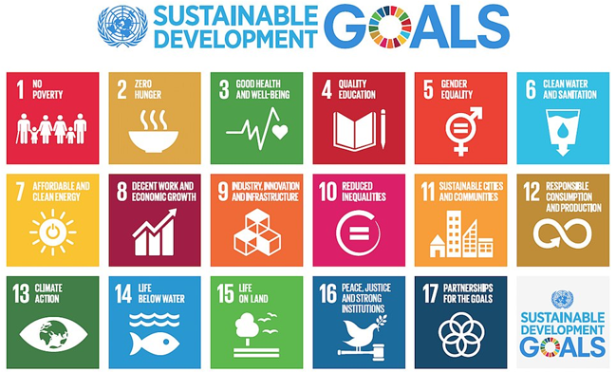
https://www.youtube.com/watch?v=9-xdy1Jr2eg&t=2s

- Work in groups of 3 students and prepare a 3 - 4-minute presentation. Your presentation should be given by just using one poster not a PPP (should be prepared together, just use keywords, numbers, pictures etc.) and make sure that each of you is familiar with all the information as everyone needs to present the topic to a group of your classmates.

Your teacher will prepare the respective channels on teams so that you can work together easily.

- Choose one of the topics below:
- global health problems
NAMES:
- children (education, violence against children, child labour etc.)
NAMES:
- world population (population explosion, ageing etc)
NAMES:
- global food production & food supply (food crisis, malnourishment, hunger etc.)
NAMES:
- substance abuse, addictions
NAMES:
- water and sanitation
NAMES:
(Tipp: Upload the word file in MS Teams. All students can fill in their names in this word file and the teacher creates the channels accordingly)
- Prepare a one-page summary of your topic, which has to be uploaded on TEAMS by … (fill in date)

- For the presentations on … (fill in date), your teacher will rearrange the channels in teams. Please make sure to switch on your cameras while presenting and don’t forget to press the RECORD button.

SOLUTION:
What are the SDGs? When were they established?
Agreed on by 193 countries in 2015 the SGDs are the world’s new action plan for the next 15 years to
- eradicate extreme poverty and hunger Beseitigung von Armut und Hunger
- fighting equality Kampf um Gleichberechtigung
- tackle climate change Bekämpfung des Klimawandels
- achieve sustainable development for all nachhaltige Entwicklung für alle erreichen

The SDGs followed the Millennium Development Goals to tackle development issues. = Entwicklungsfragen anzugehen
- positive consequences so far
- number of people living in extreme poverty has declined by more than half verringert
- more boys and girls attend primary schools besuchen
- access to water and essential medicine Zugang

Today over 800 million people still live in extreme poverty. They are also most vulnerable (am anfälligsten) to the increasing impact (Auswirkungen) from climate change and environmental degradation (Zerstörung). Years of hard-won (hart erkämpfter) progress fighting poverty could easily be wiped out by even small conflicts, economic crises or natural disasters.

Which regions achieve less progress? Sub-Saharan Africa and Southern Asia
Give examples for marginalized groups: people with disabilities, indigenous groups, rural communities,
Human prosperity (Wohlstand) must go hand in hand with protecting the planet.

Name some of the 17 sustainable development goals
- compare image

The SDGs tell us we should LEAVE NO ONE BEHIND.
Together with the Paris Climate Change Agreement and the Pope’s encyclical laudato si the SDGs provide a new framework for approaching sustainable development.

