Let’s collect our favourite Christmas songs.
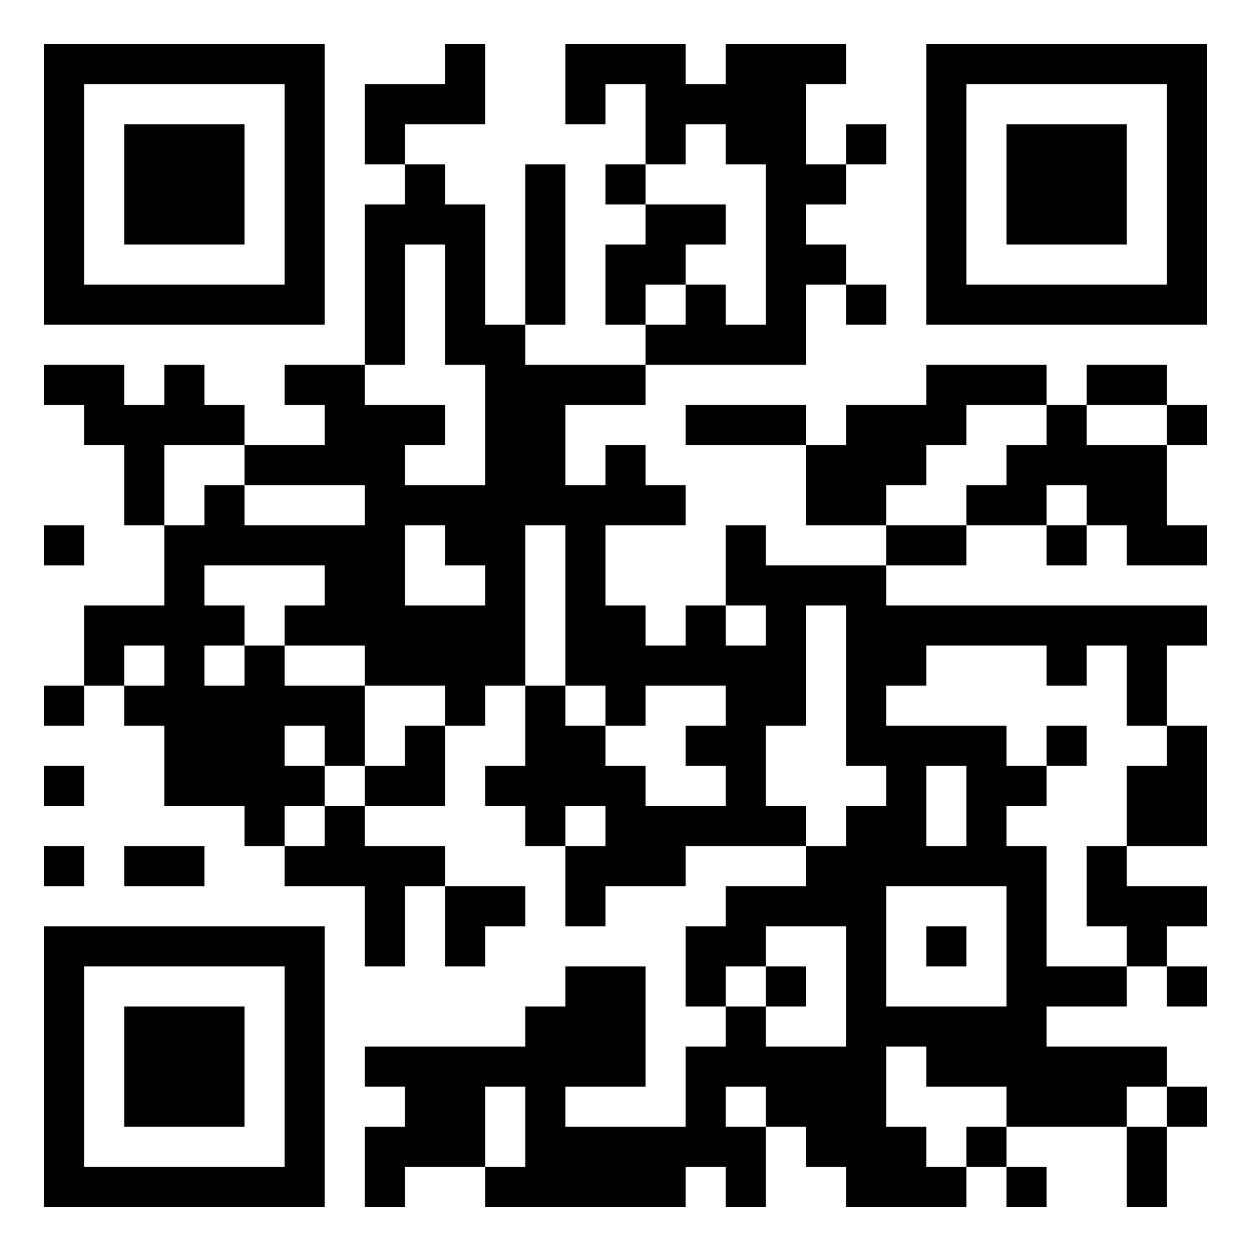
Open the padlet: https://padlet.com/atzlesberger/wrl79dppnjzjo3f9
(Jeder Lehrer/in sollte sein/ihr eigenes Padlet erstellen)

And what is your favourite Christmas song?
Sharing is caring. Please upload the link on the padlet! … Finished?

Now listen to at least three songs of your colleagues and write a short comment.
Comment on:
How you like the music
How you feel while listening (does it lift your mood?)
How you like the lyrics
How you like the band / singer / group
And what about the video?

Let’s train your listening skills. Open a free lyricstraining account: https://lyricstraining.com

a) Select language (English ) and look for your favourite Christmas song.

b) Have you found it? If not choose any song and select a game mode.
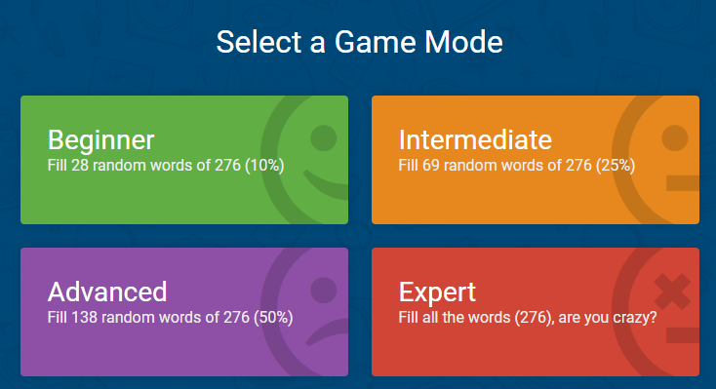
c) Listen carefully and fill in the gaps. Have fun!
for example: Taylor Swift - Christmas Tree Farm
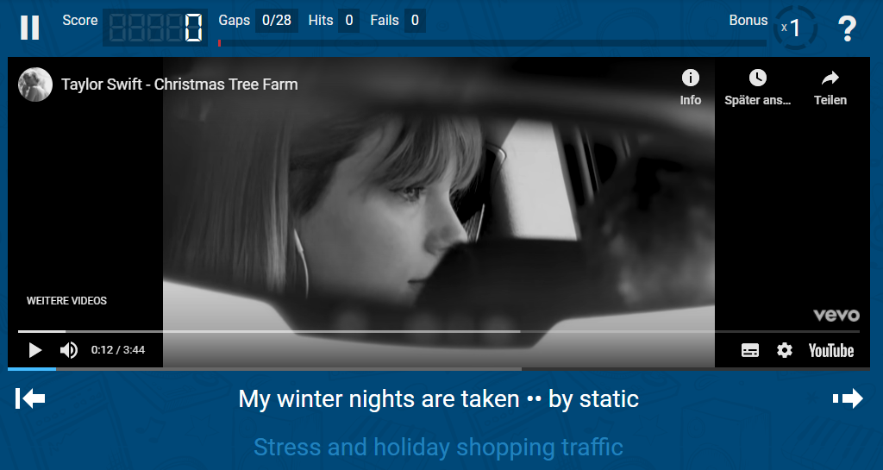

d) Retry on a more difficult level!

