Competences | Reception, spoken production, creative writing, processing text in writing (mediating a text)
Levels | English: B2, Spanish: B1
Topics | Emotions, fields of personal interest
Methods | Work in pairs
Time needed | Approx. 100 min
Requirements | Students know the majority of adjectives in English. Spanish equivalents will be learnt during the lesson.
Materials | BYOD (smartphones, laptop)
Sources | Tasks 1 & 2: Based on an idea by Nicky Hockly, ETPedia Technology, 2017, S. 33

Picture your feelings

Tarea / Exercise 1 😊😊

Work on your own. Here are a couple of emojis and their meaning in English.
Try to fill in the appropriate expression in Spanish. Use a dictionary to help you.

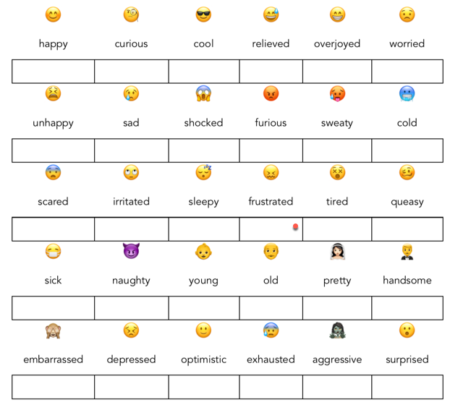

Tarea / Exercise 2 😊😊

Elegid entre 5 y 6 adjetivos de la tarea anterior y haced un selfie expresando esta emoción.
Guardad las fotos.

Tarea / Exercise 3 😊😊

Collaborate with another partner. Show each other the selfies you took. The new partner tries to guess the emotion you were trying to express, giving the English as well as the Spanish adjective.

Use Quizlet and create a new file if there are adjectives you don’t know yet or which you have forgotten. Practice frequently! Recycling = memorizing!

Tarea / Exercise 4 😊😊

What kind of feeling is expressed by the following adjectives? Find a suitable headline.
¿Qué sentimiento expresan los adjetivos siguientes? Relacionad los títulos.
Work with a partner. Trabajad en parejas.
Look for an adequate English and Spanish heading.

Ayuda en español: sorpresa / miedo / ira / tristeza / felicidad

happy – feliz  glad – contento  joyful – alegre  optimistic – optimista | startled – sorprendido  amazed – alucinado  excited – emocionado  confused – confundido | scared – asustado  fearful – miedoso  frightened – aterrado  anxious – nervioso | mad – enfadado  furious – furioso  aggressive – agresivo  angry – enfadado | depressed – deprimido  lonely – desolado  guilty – culpable  sad – triste

Tarea / Exercise 5 😊😊

Creative (plurilingual) writing

Step 1: Escribe una breve historia en español usando por lo menos 6 adjetivos que has aprendido.

Step 2: Comparte la historia con un compañero/a.

Elige una de las tecnologías disponibles.

Step 3: Save a copy of your partner’s file using a new file name.
Rewrite your partner’s story in English and try to develop it, adding more details.
Share the file with your partner again.

Step 4: Resume la historia de tu compañero/a en un cómic.
Ve a https://toontastic.withgoogle.com y crea un cómic. (Tarea en casa o lleva el portátil/la tableta a clase)

