Kompetenzen | Lesen, Schreiben, Sprechen
Niveau | B1-B2
Themenbereiche | Citizenship, Ethik, Menschenrechte
Methoden | Einzelarbeit, Pair Work
Zeitbedarf | 2 Einheiten
Eingangsvoraus-setzungen | S/S verfügen über ausreichenden Wortschatz zum Thema Frieden, Krieg, Zusammenleben und haben grundlegende Kenntnisse im Bereich Lyrik
Materialien | Pen & Paper / writing app
Quellen | Eigene Idee  Gedichte:  Maley, A. (ed.) The Pity of War… The Poetry is in the Pity. PeacheyPublications Ltd., 2022.  The Pity of War… The Poetry is in the Pity. Reflections on the Invasion of Ukraine by Russia. File 1. Original poems.
Details zur Aufgabe | Mit dieser Aufgabe soll den Schülerinnen und Schülern die Möglichkeit gegeben werden, den Krieg in der Ukraine zu thematisieren. Emotionen können aufgeschrieben und kanalisiert werden.  Als literarische Vorlage eines stream-of-consciousness Textes bietet sich „The Love Song of J. Alfred Prufrock” von T.S. Eliot an.
TechTools | Eine Möglichkeit, die Arbeiten dann ev. auch zu veröffentlichen, bieten zum Beispiel:  BookCreator  Allpoetry.com  Generell eignet sich aber natürlich auch Padlet um Inhalte für andere sichtbar zu machen. (Hier könnte man auch speziell mit der Kommentarfunktion arbeiten, um Reflexion zu ermöglichen).

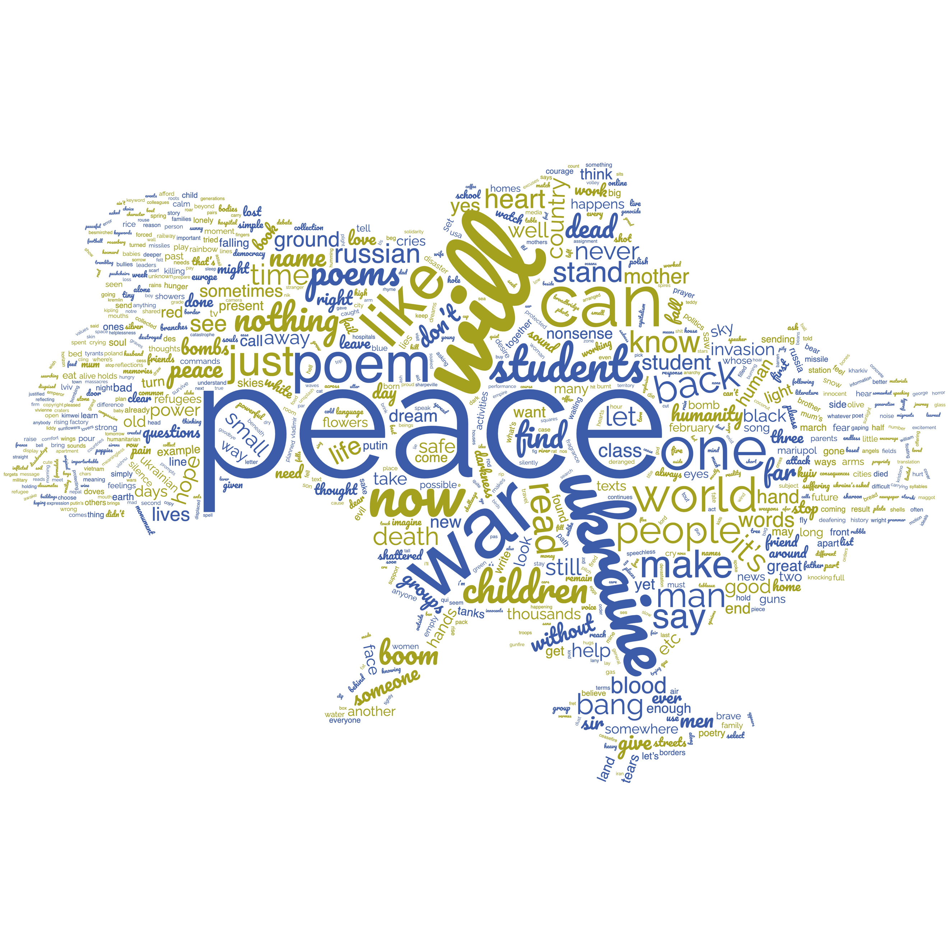
Poetry in Times of War

Task 1
Getting started
In groups of 2, brainstorm ideas, words, and phrases that you think will come up in a poem about war and peace.

Task 2
What a poem makes me think of …
- Choose one of the poems on the next page and read it.

- After you have finished, note down some of your
thoughts and feelings.

- Find one or two people who have read the same poem
and talk about your thoughts.

This wordle is based on “The Pity of War”, Maley et.al, 2022
POEM 1  Refugees. Author unknown.  They have no need of our help  So do not tell me  These haggard faces could belong to you or me  Should life have dealt a different hand  We need to see them for who they really are  Chancers and scroungers  Layabouts and loungers  With bombs up their sleeves  Cut-throats and thieves  They are not  Welcome here  We should make them  Go back to where they came from  They cannot  Share our food  Share our homes  Share our countries  Instead let us  Build a wall to keep them out  It is not okay to say  These are people just like us  A place should only belong to those who are born there  Do not be so stupid to think that  The world can be looked at another way  (NOW READ FROM BOTTOM TO TOP) |  | POEM 2  She had nothing to eat. © Michael Swan  She had nothing to eat.  They made a film about her  because she had nothing to eat.  Her husband was killed in the war  They wrote a book about  how he was killed in the war.  Her brother and mother were executed by the revolutionary guards.  There was an opera about it.  Both her children died  (there was no hospital)  You can see the photographs at an exhibition in London.  Then somebody wrote a poem.  Still - she had nothing to eat.

POEM 3  Love Now. Catherine Bryden  History. Present.  Confusing. Bewildering.  Shattered. Dead.  Ideals. Idealism.  Borders. Separations.  Real. Artificial.  Agreements. Disagreements.  Aches. Dreams.  Truths.  Love.  Now. |  | POEM 4  All right, Jack? Rod Bolitho  In my time, too  I have passed by  On the other side;  Have counted blessings,  Muttering ‘There, but for  The grace of God  Go I.’  But when people in their thousands die  With no last chance to say goodbye,  When parents from their children part  And wave farewell with broken hearts,  Not knowing if on that same day  With their lives they’ll have to pay  For holding firm to hope and right  Despite the threat of Kremlin might,  Can we stand by and simply say,  ‘Don’t cross our borders, no, no way!  No more migrants, mouths to feed,  We Brits are quite a different breed.  It’s not our war. Don’t get involved.  It’s theirs and Putin’s, problem solved.  It’s Easter soon, let’s plan our trip.  Covid’s over, let’s let rip!’?

Task 3
Collecting ideas
In groups of 2, brainstorm ideas, words, and phrases that you might like to use in a poem of your own that deals with war and peace.

Task 4
Writing my own poem
Work on your own.
Try to write a poem. It can be as long or as short as you wish. You can use one of the poems you have read as a model.
If you are not happy writing a poem you might want to try writing a text using the stream-of-consciousness technique. This basically means you write down your ideas just as they come into your mind. It is a form of free writing, an interior monologue which mimics the way people think.

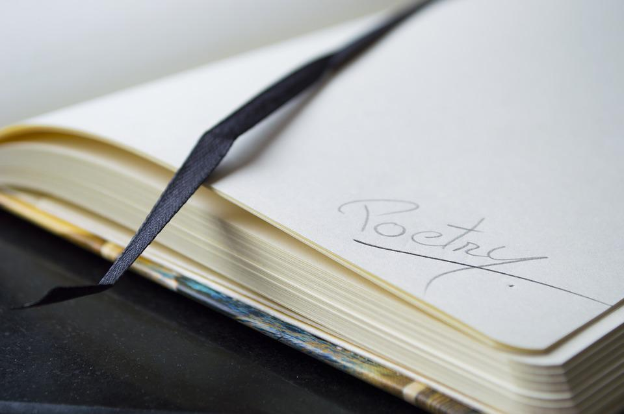
Task 5
Sharing
Decide how you would like to share your poem with others:
- Find two or three other people.
Read each other’s poems and talk about your impressions.
- Upload it to a padlet so others can comment on it.
- You could also publish your poem online.

https://pixabay.com/de/photos/notizbuch-noten-schreibwaren-2246457/

