Kompetenzen | Lesen, Sprechen, kreatives Schreiben, ...
Niveau | B2
Themenbereiche | Tourismus
Methoden | Einzelarbeit, Partnerarbeit, Einsatz digitaler Medien
Zeitbedarf | 1-2 Einheiten
Eingangsvoraus-setzungen | S/S verfügen über ausreichenden Wortschatz zum Thema Tourismus, Reisen, …
Quellen | Eigene Idee
TechTools | ChatGPT (https://openai.com/blog/chatgpt/)  ChatGPT ist ein künstlicher Intelligenz-Chatbot. Er wurde von Open AI programmiert, um menschenähnliche Konversationen zu führen bzw. Fragen auf natürliche Weise zu beantworten.

Travel Gems
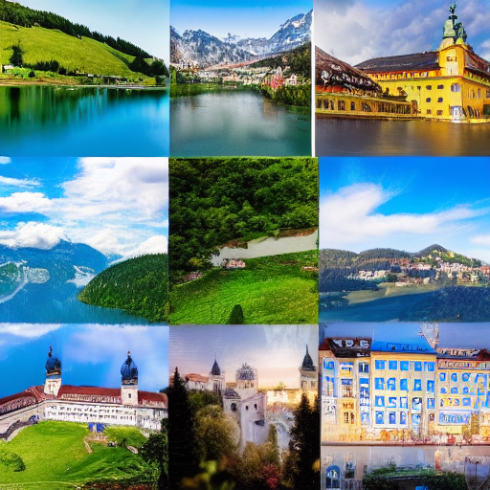.

Created with DiffusionBee ( https://diffusionbee.com) for macOS, a tool to generate AI art.

Task 1 – Introductory activity
Invite your students to briefly describe their favourite travel destinations. Here are some aspects they could consider for their descriptions:

Task 2 – Words and phrases
Put students in pairs or groups of three and ask them to note down words and phrases they would use in an advertisement promoting their favourite travel destinations, e.g. a hidden gem, breathtaking views, picturesque landscape, rolling hills, etc.

Task 2 – Reading activity
Hand out one of the sample advertisements about a travel destination in Austria generated by ChatGPT.
Alternatively, ask ChatGPT to write an advertisement about a destination of your choice.
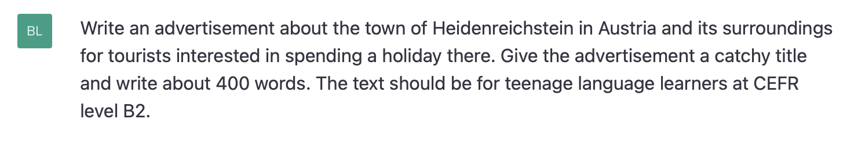
Tell students to read the advertisement and identify the advantages and possible disadvantages of the destination.

Task 4 – Speaking activity
When they have finished reading the advertisement, students discuss the advantages and disadvantages they have identified in pairs or groups of three and decide whether they would or would not recommend spending a holiday there.

Task 5 – Vocabulary grid
Students go back to the advertisement and scan it for words and phrases that are used to promote the allure and attractiveness of the destination. Then they categorise them according to some or all of the aspects given in task 1:
Location/Scenery | Culture/History | Popular activities | …
- nestled in the rolling hills  - … | - a treasure trove of historical sites  - … | - a leisurely walk  - … | - …

Task 6 – Writing activity
Students write an advertisement that aims to promote their hometown or the region they live in as a tourist destination, e.g. for a teenage travel magazine or website. Encourage them to use as many words and phrases from their vocabulary grids as possible.
N.B: Naturally, students might want to use ChatGPT to have the text written for them. It might be wise to let them write the text in class. Alternatively, students could create presentations and use Flip to share it with their teacher only or the whole group/class.

Follow-up activity
As a class, discuss your students’ advertisements and provide feedback on the use of vocabulary and organization.
Sample advertisement 1
"Discover the Hidden Gem of Heidenreichstein: Your Perfect Holiday Destination!"
Nestled in the rolling hills of Lower Austria, the town of Heidenreichstein is the perfect destination for those looking for a peaceful and relaxing holiday in a picturesque setting. This charming town is surrounded by lush forests and rolling meadows, offering plenty of opportunities for outdoor activities and scenic walks.
For those interested in history and culture, Heidenreichstein is a treasure trove of historical sites and cultural landmarks. The town's castle, which dates back to the 12th century, is a must-visit for anyone interested in medieval architecture. Visitors can also explore the town's beautiful churches and chapels, including its Gothic Roman Catholic Church, or take a leisurely stroll through the town's charming streets, which are lined with traditional wooden houses.
But Heidenreichstein is more than just a charming town with a rich cultural heritage. It is also a gateway to some of the most stunning natural landscapes in Austria. The surrounding countryside is home to a network of well-marked hiking trails, providing ample opportunities for those seeking a more active holiday. Whether you're looking for a challenging mountain hike or a leisurely walk through rolling meadows, you're sure to find something to suit your needs.
For those who prefer water sports, Heidenreichstein is just a short drive from several lakes and rivers, providing ample opportunities for swimming, fishing, and kayaking. The nearby Pielach river is especially popular among kayakers and canoeists, offering a range of scenic routes through breathtaking landscapes.
After a day spent exploring the area, visitors can relax and unwind in one of Heidenreichstein's many traditional taverns or cafes, sampling local specialties and chatting with friendly locals. There are also several comfortable and well-appointed accommodation options in the town, including hotels, apartments, and bed and breakfasts, all of which offer easy access to the town's many attractions.
So if you're looking for a holiday that offers a perfect combination of history, culture, and natural beauty, Heidenreichstein is the place for you! Whether you're seeking a peaceful getaway or an action-packed adventure, this hidden gem of Lower Austria has something for everyone. So pack your bags and come discover the wonders of Heidenreichstein today!

Sample advertisement 2
"Discover the Hidden Gem of the Waldviertel Region: Your Perfect Holiday Destination!"
The Waldviertel region in Austria is a breathtakingly beautiful area that is perfect for a holiday escape. Located in the northern part of Lower Austria, this region is surrounded by rolling hills and dense forests, offering a peaceful escape from the hustle and bustle of city life. With a rich cultural heritage and a variety of outdoor activities on offer, the Waldviertel region is the perfect destination for tourists looking for a traditional Austrian experience.
The Waldviertel region is known for its stunning natural scenery, with lush forests and rolling hills offering a peaceful escape from the hustle and bustle of city life. Hiking is a popular activity in the region, with a variety of trails suitable for all levels of fitness. Take a leisurely stroll through the countryside, or challenge yourself with a more strenuous hike to the top of one of the region's many hills. For those who prefer to see the scenery from the comfort of a bike, the Waldviertel region is a cyclist's paradise, with scenic routes that wind through charming small towns and the beautiful countryside.
The Waldviertel region is rich in history and cultural heritage, with traditional farmhouses, castles, and Gothic churches scattered throughout the area. One of the highlights of a visit to the Waldviertel region is a tour of the Heidenreichstein Castle, which dates back to the 13th century and is now used as a cultural center. The town of Gmünd is also known for its picturesque countryside and charming atmosphere, and is home to several historic buildings, including a castle, a Gothic church, and traditional farmhouses.
The Waldviertel region is also known for its traditional festivals and events, such as the annual "Waldfest" forest festival and the "Heidenreichsteiner Kirtag" town fair. These events offer a glimpse into the local culture and provide a fun and festive atmosphere for tourists to enjoy. Whether you're interested in trying traditional Austrian food, listening to local music, or simply soaking up the atmosphere, these events are a must-visit for anyone spending a holiday in the Waldviertel region.
In conclusion, the Waldviertel region in Austria is a fantastic destination for anyone looking for a holiday escape. With its stunning natural beauty, rich cultural heritage, and a variety of outdoor activities on offer, this region is the perfect destination for those seeking a traditional Austrian experience. So, pack your bags and head to the Waldviertel region today!
The information in red is incorrect. It was left in the text on purpose. ChatGPT ist far from perfect.

