Kompetenzen | Mediation: Processing text (pictures) in speech
Niveau | A2
Themenbereiche | Housing
Methoden | Pair work  Classroom discussion
Zeitbedarf | 1 lesson
Eingangsvoraus-setzungen | S/S verfügen über ausreichenden Wortschatz, um Häuser, Möbel, Familie und das Wetter zu beschreiben. S/S kennen prepositions of location  S/S sind vertraut mit Verwendung present simple / progressive
Methodisch-didaktische Hinweise | - Students sit in pairs. Student A faces the screen. Student B faces student A  - Until 3:02 min. student A describes what they see to student B  - Swap positions. Now student B describes what they see to student B until 4:45 (until mum starts feeling unwell)  - Classroom discussion (elicit answers to the following questions)  - Which furniture do you see in this short film?  - Which emotions are displayed by the protagonists?  - What is “home” in this short film?  - How is “home” defined by the protagonist’s mother?  - They watch the movie from the beginning again.  - Stop again at 4:45  - Let them predict what is going to happen.  - They finish watching the movie together.  - Ask students about how they feel/how they liked it/what they think about it (e.g. the movie’s message)
Materialien | Beamer, YouTube  https://www.youtube.com/watch?v=nTB61iR6cVQ
Quellen | Eigene Idee

The time has come that a young adult man must leave his parental home and stand on his own two feet, or so his father believes. The boy sets out to the world, but somehow it is impossible for him to leave. In this light, absurd, and comical little drama, the boy's journey is obstructed by the weirdest of reasons. Or is there something else holding him back?

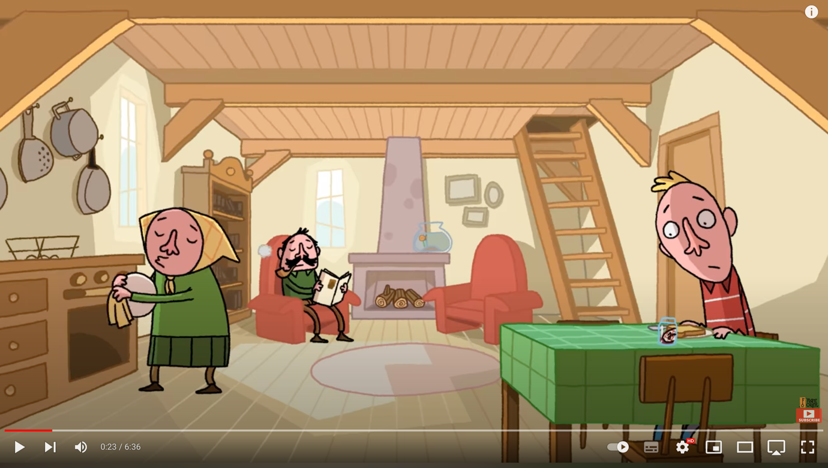

Leaving Home – A Tragicomedy

This lesson is based on a short film from the Netherlands.

Task 1
Viewing comprehension + telling the story
- Sit in pairs. Student A faces the screen. Student B faces student A
- Until 3:02 min. student A describes what they see to student B
- Swap positions. Now student B describes what they see to student B
until 4:45 min.

Task 2
Discussion questions:
Which furniture do you see in this short film?
Which emotions are displayed by the protagonists?
What is “home” in this short film?
How is “home” related to the protagonist’s mother?

